Using Zoom
Zoom is a web conferencing software that enables multiple people to participate in a class or session at the same time. This guide will help you with the following:

Creating a Zoom account 1
Creating a Zoom meeting 4
Sending a Zoom meeting invitation to the participants 6
Opening a Zoom meeting 7
Sharing your Screen 8
Engaging your Zoom participants 13
Recording your Zoom session 16
Ending your Zoom session 16
Other Zoom Features 16

Creating a Zoom account
If you already have a Zoom account, skip to page 4.
To begin, log into Zoom (https://zoom.us/) on any web browser. If you have not used Zoom in the past, click on blue “Sign Up, It’s Free” button in the upper right hand corner.
When the new screen appears, enter your Cambridge College email address in the box under “Your work email address”
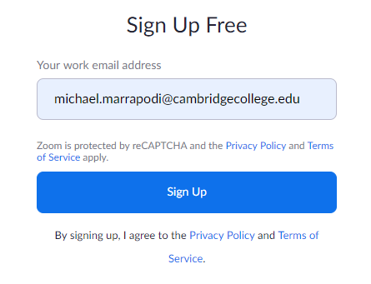

You will then see the following:
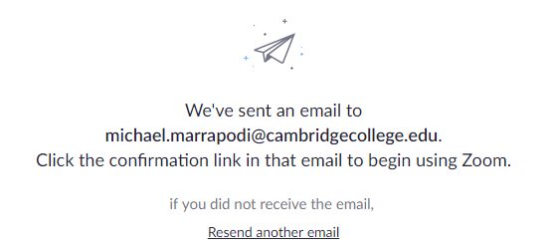
Check your Cambridge College email for the Zoom response.
The email should look like this:
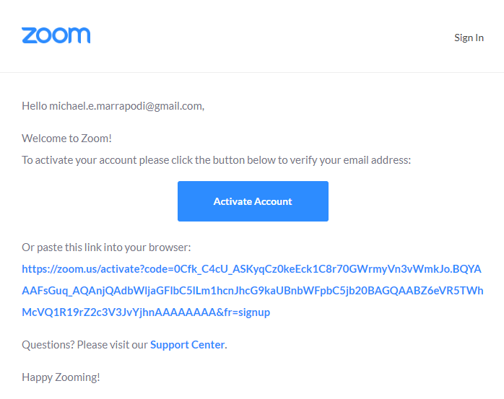
Click the blue “Activate Account” button
On the new screen, fill out your First Name, Last Name, and Password, then, confirm your password and click the orange “Continue” button.
The next screen may ask you to recommend Zoom to a colleague. Click on the white “Skip this step” button to continue.
On the next screen, you will receive your personal meeting URL:
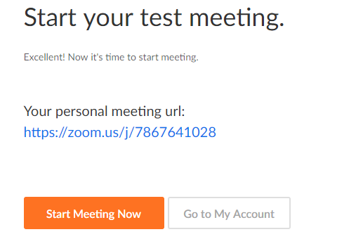
111

If you click on the white “Go to My Account” button, you will be taken to your account information page. From there, you can check your account information and you can Schedule a Meeting, Join a Meeting, or Host a Meeting.
The free Zoom plan includes a 40-minute time limit on meetings with 3 or more participants. To upgrade, contact IT through the Help Desk and request an upgraded Zoom account.
Continue to the next page to begin setting up meetings and inviting participants.

Creating a Zoom meeting
Enter zoom.us into your browser. When the Zoom platform appears, click on SIGN IN in the upper left corner of the screen. Enter your email address and password, then click the blue “Sign In” button. This will take you to your account page.
To schedule a new Zoom meeting, click on SCHEDULE A MEETING at the top of the page. You will then see the following:
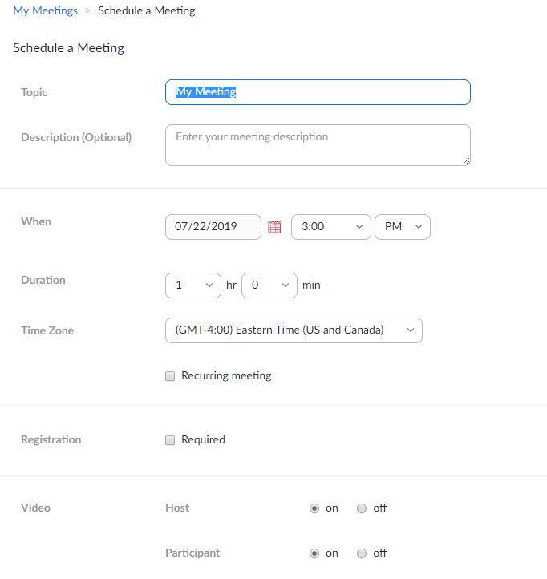
Enter the name of the meeting and an optional description. Choose the date and time and the length of the meeting (Duration). Adjust the Time Zone if necessary (Eastern is the default). Typically, the registration is not required; however, you can check the box next to Required if you want students to register before they can access the session. Video for Host and Participant defaults to on; these settings aren’t usually changed.

For the remaining items:
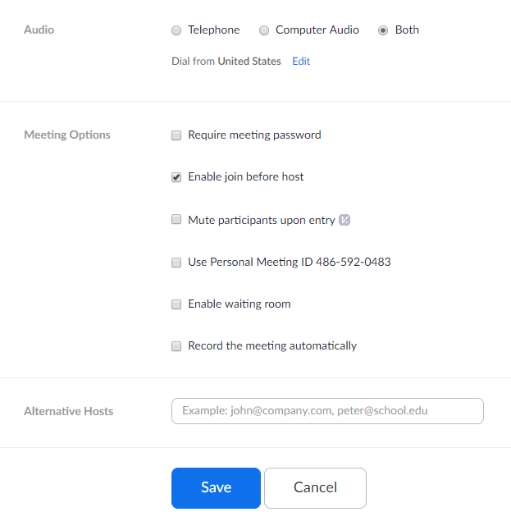

The Audio setting should be left at “Both.” There are several choices for Meeting Options. “Enable join before host” should be checked so your participants are not waiting for you to open the session before they can log in. The other choices are not typically selected but feel free to experiment with them if you would like to do so. You may also designate an alternative host by typing an email into the Alternative Hosts box. Separate multiple names with a comma.
Click on the blue “Save” button to continue.

When the new screen appears, confirm the meeting details.
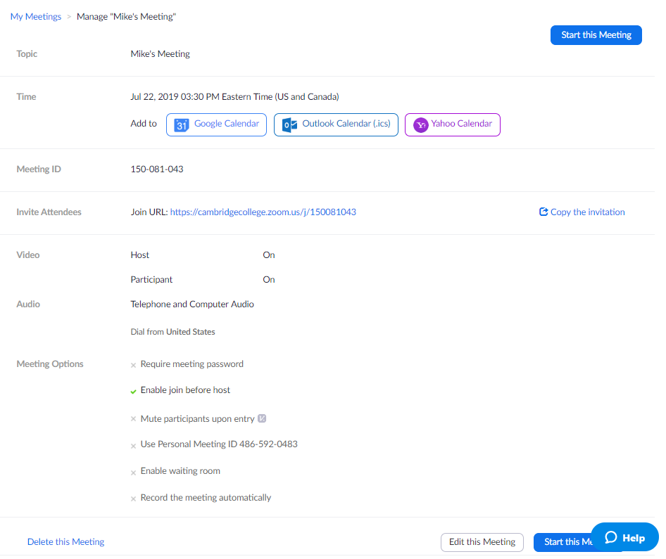
If/When you are ready to start the meeting, navigate back to this page and click on the blue “Start this Meeting” button on the top or bottom of the screen. You can also delete the meeting (click on Delete this Meeting at the bottom of the screen) or change details about the meeting (click on the white “Edit this Meeting” button at the bottom of the screen).

Sending a Zoom meeting invitation to the participants
You can invite attendees in 2 ways: by copying the Join URL in the center of the page above and sending it to them, or by clicking on the right side of the screen. This will produce a new screen:
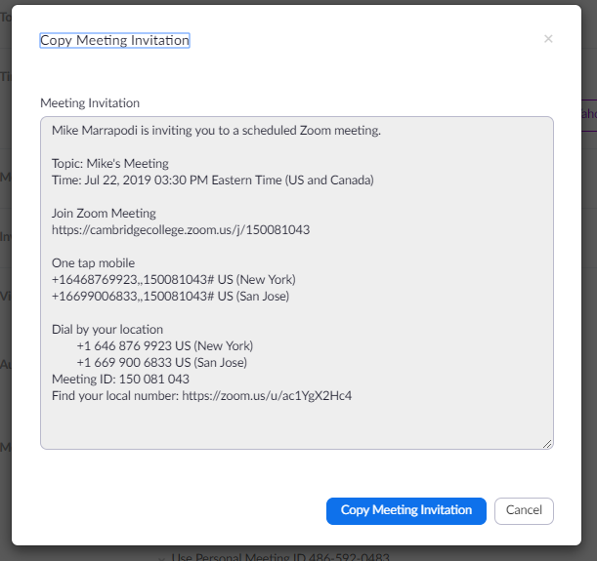
Click on the blue “Copy Meeting Invitation” button on the bottom of the screen which will place the invitation on your clip board. Navigate to an email or another document and select paste to paste this information into the new area.

Opening a Zoom meeting
- In the Zoom client, click Meetings.
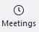
- Under the Upcoming tab, select the meeting you want to start. Additional options will appear.
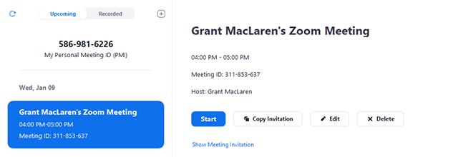
- Click Start.

Sharing your computer screen with your Zoom participants
Click here for a short video or follow the instructions below.

Sharing your Screen
- Click the Share Screen button located in your meeting controls.
- Select the screen you want to share. You can also choose an individual application that is already open on your computer, the desktop, a whiteboard, or an iPhone/iPad.
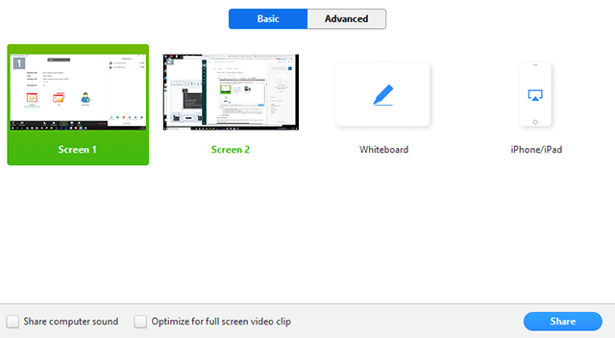
- (Optional) Enable these features:
  - Check Share Computer Sound: If you check this option, any sound played by your computer will be shared in the meeting.
  - Check Optimize for full screen video clip: Check this if you will be sharing a video clip in full screen mode. Do not check this otherwise, as it may cause the shared screen to be blurry.
- Click Share.
Screen Share Menu
When you start sharing your screen, the meeting controls will move into a menu that you can drag around your screen.
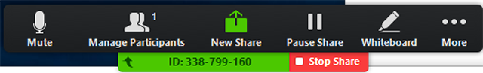
- Mute/Unmute: Mute or unmute your microphone.
- Start/Stop Video: Start or stop your in-meeting video.
- Participants/Manage Participants: View or manage the participants (if the host).
- New Share: Start a new screen share. You will be prompted to select which screen you want to share again.
- Pause Share: Pause your current shared screen.
- Annotate: Use screen share tools for drawing, adding text, etc.
- More: Hover over move for additional options.
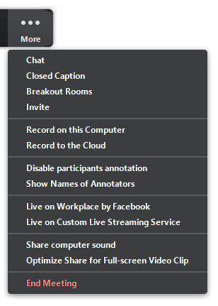
  - Chat: Open the chat window.
  - Invite: Invite others to join the meeting.
  - Record: Start recording locally or to the cloud.
  - Allow/Disable participants annotation: Allow or prevent the participants from annotating on your shared screen.
  - Show/Hide Names of Annotators: Show or hide the participants' name when they are annotating on a screen share. If set to show, the participant's name will briefly display beside their annotation.
  - Live on Workplace by Facebook: Share your meeting or webinar on Workplace by Facebook. Learn more about live-streaming a webinar.Learn more about live-streaming a meeting.
  - Optimize Share for Full-screen Video Clip: Start optimizing for a video clip in full screen mode. We do not recommend using this if you are not sharing a full screen video clip, as it may blur your screen share.
  - End Meeting: Leave the meeting or end the meeting for all participants.

Annotation
Select Annotate to begin annotating on your shared screen.
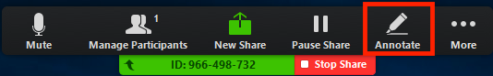
This will open the annotation menu.
You can use the following annotation tools:
- Mouse: Deactivate annotation control and switch back to your mouse pointer.
- Select: Select, move, or resize your annotations.
- Text: Insert text.
- Draw: Insert lines, arrows, and shapes.
- Stamp: Insert predefined icons like a check mark or star.
- Spotlight/Arrow: Turn your cursor into a spotlight or arrow.
- Eraser: Click and drag to erase parts of your annotation.
- Format: Change the formatting options of the annotation tools.
- Undo: Undo your latest annotation.
- Redo: Redo the latest annotation that you undid.
- Clear: Delete all annotations.
- Save: Save all annotations on the screen as a screenshot. The screenshot is saved to the local recording location.
Dual Monitors
If you are using a dual monitor set-up, you can turn on the Use Dual Monitors feature to see the screen sharing on one monitor and participants on the second.
Note: On Mac OS 10.15 Catalina, you need to allow Zoom access to Screen Recording to share your screen. You can do this in your System Preferences > Security & Privacy >Privacy > Screen Recording. Check the option for zoom.us.
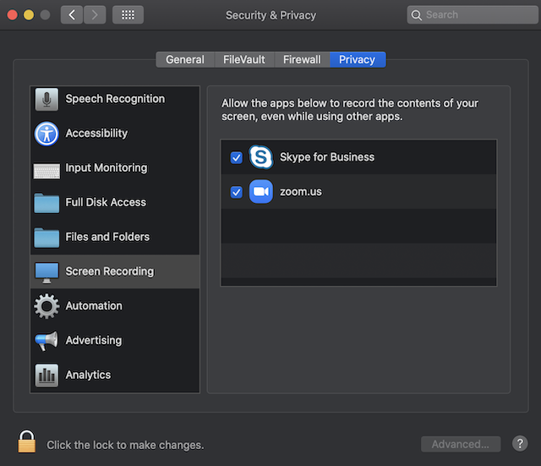

Engaging your Zoom participants

Using the Chat feature in Zoom
- While in a meeting, click Chat in the meeting controls.
- This will open the chat on the right. You can type a message into the chat box or click on the drop down next to To: if you want to send a message to a specific person.
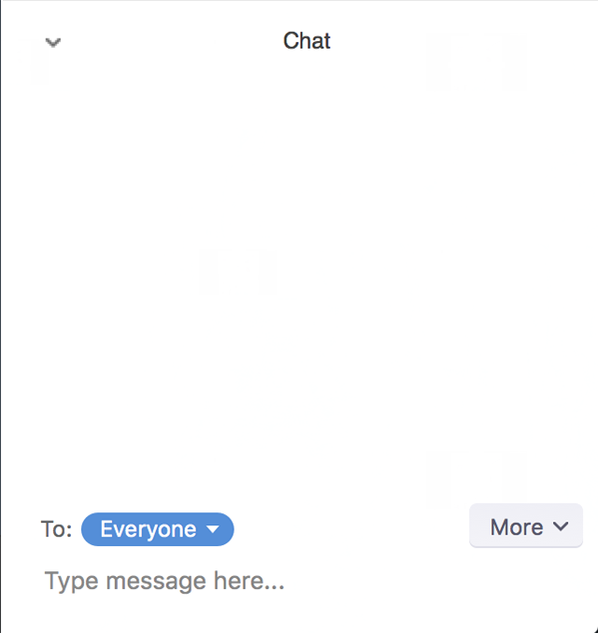
- When new chat messages are sent to you or everyone, a preview of the message will appear and Chat will flash orange in your host controls.
While Screen Sharing
- While screen sharing, click More in the meeting controls. Choose Chat.
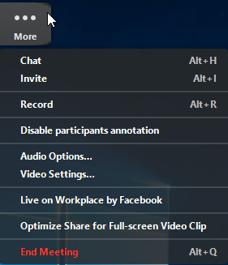
- A floating chat window will appear.
- If you receive new chat messages while screen sharing, the More button will flash orange to indicate the incoming message. You can click on More, then Chat to open the window.
Accessing the Chat in a Webinar from a Mobile Device
- While in a meeting, tap the screen to make the controls appear.
- Click on Participants.
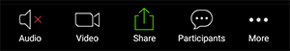
- At the bottom of the participants list, click on Chat.
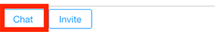
- You can type your chat message and click Send, or if you want to change who it is being sent to, click the arrow next to Send to: and choose a different person or group of people.
- Incoming chats will be displayed at the bottom of your screen and you can click on Participants then Chat to view them.
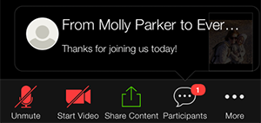
Changing In-Meeting Chat Settings
If you're the meeting host, you can change the in-meeting chat settings.
- While in a meeting, click Chat in the meeting controls.
- Click More to display in-meeting chat settings.
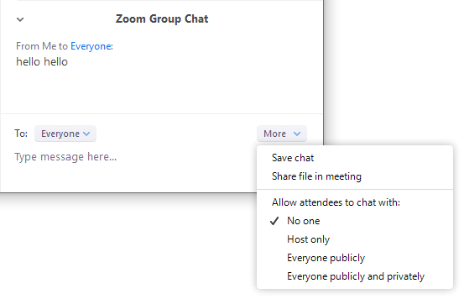
- You can access the following options:
  - Save chat: Save all chat messages in a TXT file.
  - Share file in meeting: Send a file in the chat.
  - Allow attendees to chat with: Control who participants can chat with.
    - No one: Disables in-meeting chat.
    - Host only: Only the host can send messages to everyone. Participants can still send private messages to the host.
    - Everyone publicly: Participants can only send public messages. Public messages are visible to all participants. Participants can still send private messages to the host.
    - Everyone publicly and privately: Participants can send public or private messages. Public messages are visible to all participants. Private messages are sent to a specific participant.

Recording your Zoom session
Click here to view a video on recording your Zoom sessions.

Ending your Zoom session
Click the red End Meeting on the top menu bar to end the session.

Other Zoom Features
There are many other features available in Zoom. Click here for additional videos that demonstrate the many options in Zoom.
Questions? Contact Mike Marrapodi (Michael.marrapodi@cambridgecollege.edu) or Brooks Winchell (brooks.winchell@cambridgecollege.edu)

