**Zoom Guide for Students**

This guide is designed to help you navigate the Zoom conferencing platform. If your instructor chooses to use Zoom in place of an in-seat class, or if Zoom is an option that your instructor provides if you are unable to attend an in-seat session, you will receive an email with the Zoom session information. It looks like this:

This identifies the individual who is inviting you to the session

Mike Marrapodi is inviting you to a scheduled Zoom meeting.

Topic: Zoom session

Time: Mar 17, 2020 06:00 PM Eastern Time (US and Canada)

This provides the day and time of the session. 

Join Zoom Meeting

<https://cambridgecollege.zoom.us/j/978799565>

Using your laptop, tablet, or internet-enabled phone, click on this link to begin the session

This is the meeting ID if you need it

Meeting ID: 978 799 565

One tap mobile

+16468769923,,978799565# US (New York)

If using your mobile phone, click on the “One tab mobile” number to join the session

+16699006833,,978799565# US (San Jose)

Dial by your location

If using your phone, you can also dial one of these numbers to join the session

+1 646 876 9923 US (New York)

+1 669 900 6833 US (San Jose)

Meeting ID: 978 799 565

Click on this link to find an international number to call in to the session if needed

Find your local number: <https://cambridgecollege.zoom.us/u/ac1YgX2Hc4>

Zoom may be accessed from any computer (desktop or laptop), tablet, or internet-enabled cell phone. You can also call in directly with your cell phone, but you will only have the audio portion of the session and not the video portion. You are strongly encouraged to access the session with the video option so if your instructor shares information through PowerPoint or other means, you will be able to see it.

Once you have clicked the link above, the following screen will open:

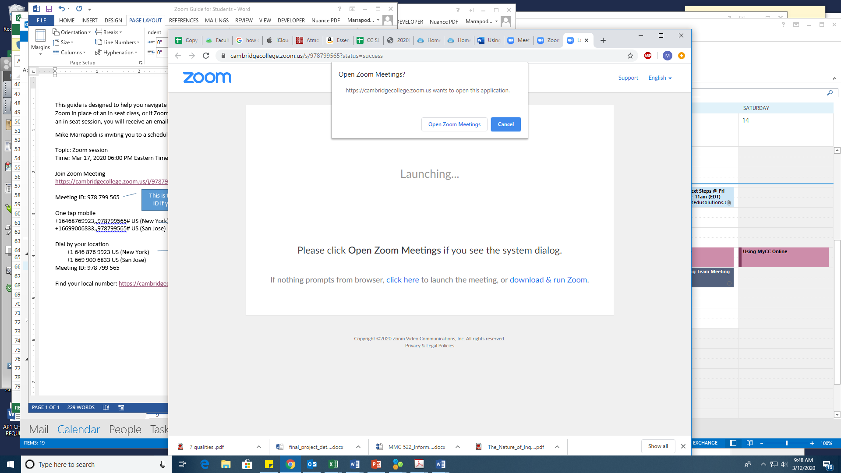

Click on Open Zoom Meetings to begin. You will see the following when you join the conference:

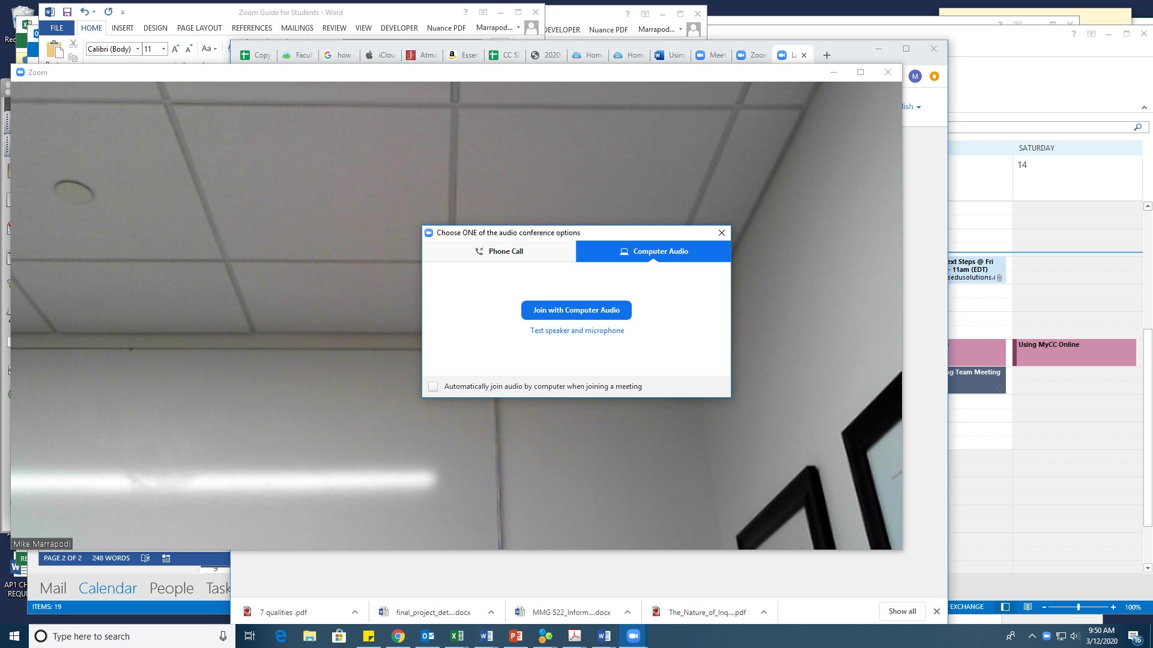

Click on Join with Computer Audio if you have a microphone connected to your computer. You can test your speaker and microphone buy clicking on Test speaker and microphone and following the prompts on the screen.

If you do not have a microphone or speakers on your computer, you may also join by phone. Click on the Phone Call tab and use the number on the screen to dial in to the session. It will look like this:

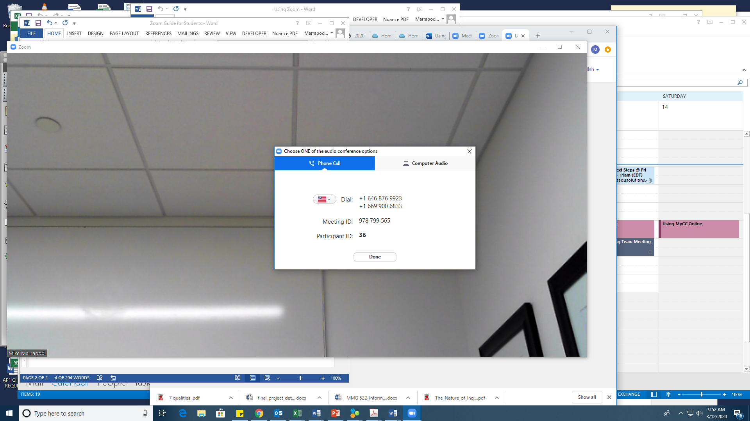

Click Done when you have connected by phone to continue with the session.

**NOTE:** Do not use your computer microphone and speakers and your mobile phone at the same time for the session. This will cause feedback and distortion of the sound for all session participants.

You have several options for participation once you have entered the session. Move your computer mouse around the screen until you see a black band at the bottom of the screen that looks like this:

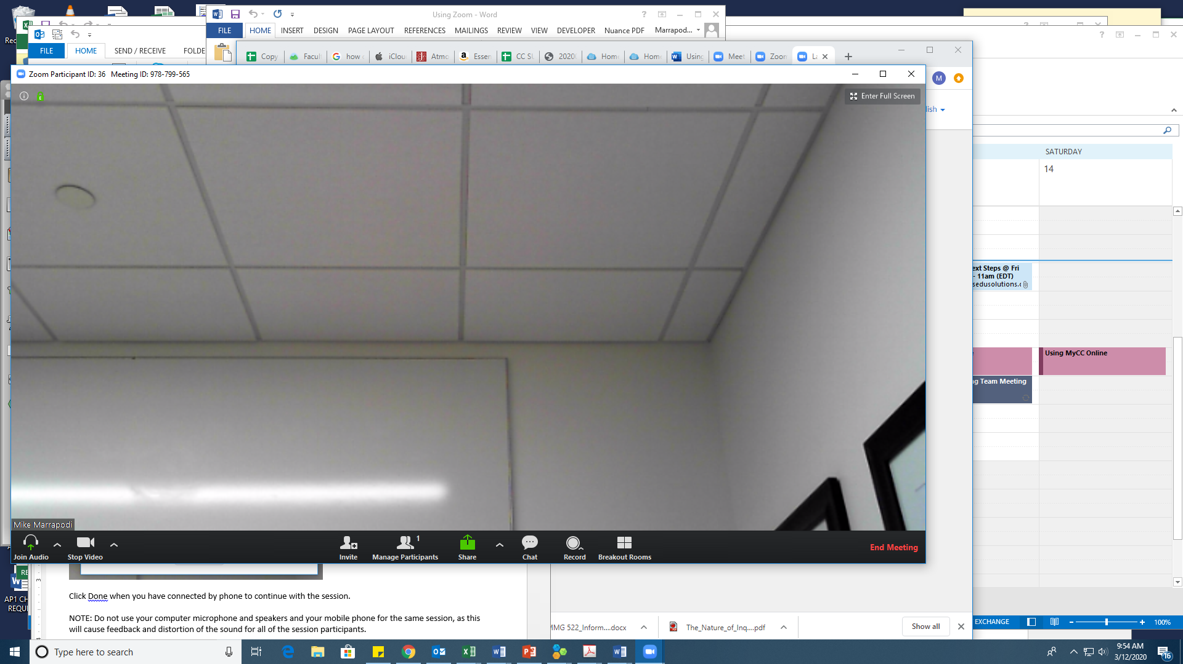

On the left side of the bar, you can control your audio (muting your microphone is recommended unless you need to speak to the class) and your video.



On the right side of the bar, you can click on Chat to type a message to the class, a classmate, or the instructor. If your instructor is using Breakout Rooms, you access those areas here as well.



If you have questions about using Zoom, please contact Dr. Mike Marrapodi, Dean of Online Programming ([Michael.marrapodi@cambridgecollege.edu](mailto:Michael.marrapodi@cambridgecollege.edu)) or Brooks Winchell, Director of CELT ([brooks.winchell@cambridgecollege.edu](mailto:brooks.winchell@cambridgecollege.edu))

You may also access tech support by calling 1-877-434-4997 and choosing option #2. They are available 24 X 7.