**Accessing Courses in MyCC**

To access your course, log onto MyCC and click on “My Courses” in the bottom left of your screen under “Quick Links”.

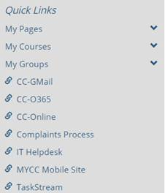

Once you are into your course, click on “Course Organizer” to view your assignments by week.

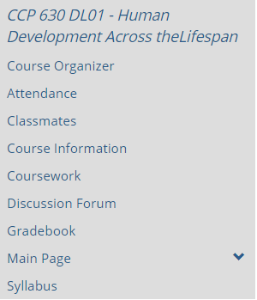

Once in “Course Organizer,” you can view your assignments week by week including discussions.

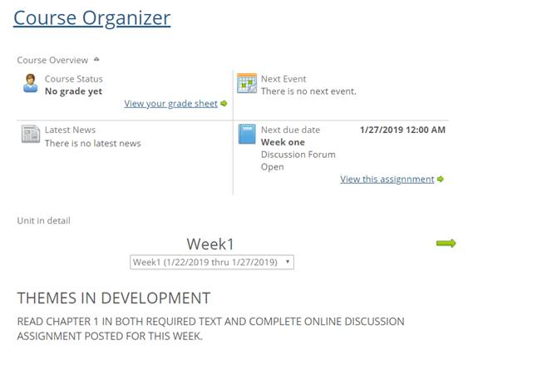

If you have any trouble with the functionality of the course, please let your instructor know. You can also reach out to the Dean of Online Programming, Dr. Mike Marrapodi at [Michael.Marrapodi@cambridgecollege.edu](mailto:Michael.Marrapodi@cambridgecollege.edu).